Instructions on using „Razgovarajmo“ app

The app Razgovarajmo is used to connect users who need psychosocial support with volunteering psychologists who will provide it. The app is free as well as the service itself and for Android systems it can be downloaded here:

https://play.google.com/store/apps/details?id=admin.com.psihosocijalnapodrska

Upon installation, there are following options to choose from:

- Psychosocial support to general population (Psihosocijalna podrška građanima i građankama)
- Psychosocial support to Red Cross volunteers (Psihosocijalna podrška volonterima Crvenog krsta)

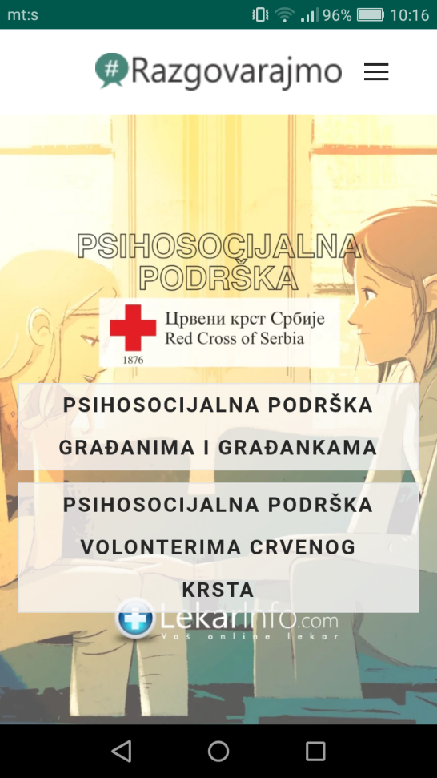

Upon choosing the adequate option you will be taken to the scheduling page. Here you type in your gender (pol), age (godine) and e-mail address where you will get the confirmation and a link for the support session with the psychologist. Please make sure you have typed in the e-mail address correctly before clicking „send“ („Pošalji“). You will also be able to choose which type of support you want: text based, audio based and full video-chat. You can choose freely.

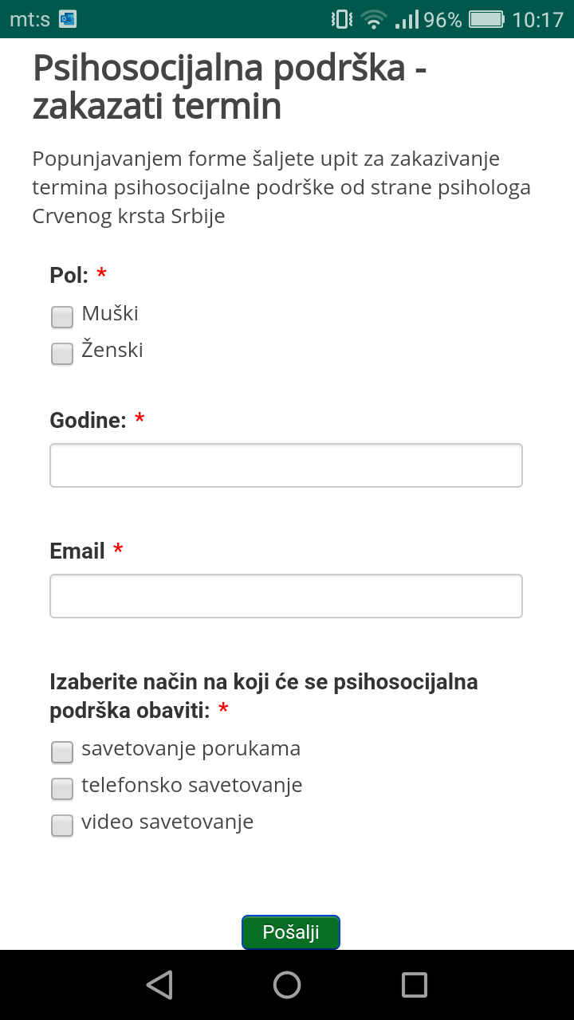

The link you will use to get in the session with the psychologist will be sent to the e-mail address you provided.

The video-chat/ session can be started at the scheduled time by clicking the link you received through email or in a text message and it will take you to the session screen.

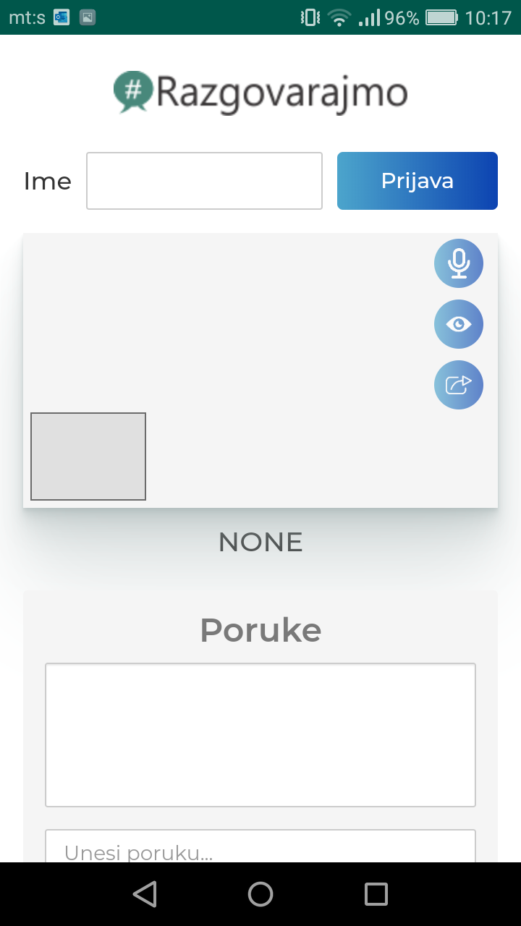

On top (or, if using it on a computer, on the left hand side) is the field where you will type in your name for the session and click „Submit“ („Prijava“) to start the session. Below is the field for the video feed for your and the psychologist’s camera. To the right of this field are the small icons that let you disable or enable video and audio functionality. They are on by default and when turned off will be crossed.

At the bottom (or on the right hand side if on a computer) is the text chat field. Here you can type messages and submit them by clicking „Pošalji“. This is where the text replies from the psychologist will appear as well.

